Short Term Online Classes in Vedic Maths were conducted by Shiksha Sanskriti Uthan Nyas for the classes III-VIII from 26th May to !st June,2020

Category:III-IV

Master Manik S/o Sh.Sandeep Kumar student of IIIA secured 100/100,thereby placed at First Position in the Country.

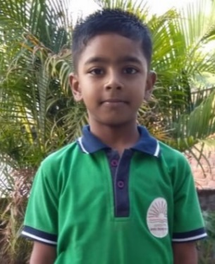

Category:VII-VIII
Ku.Vanshika Lochan D/o Sh.Ajeet Kumar student of VIIIC secured 98/100,thereby placed at First Position in the Country.

The results were announced online and link is placed below:

https://www.facebook.com/ShikshaSanskriti/videos/298965651271324/

